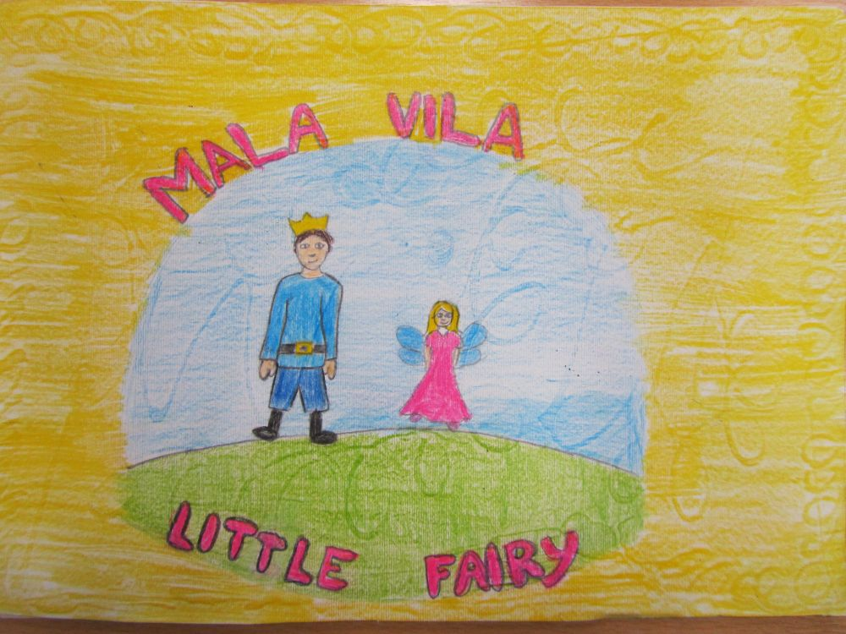

One upon a time there lived a King and a Queen and their only child, the Prince.
When the Prince was older, the King and the Queen had a big ball in his honor. At the ball many girls were dancing and looking at the Prince.

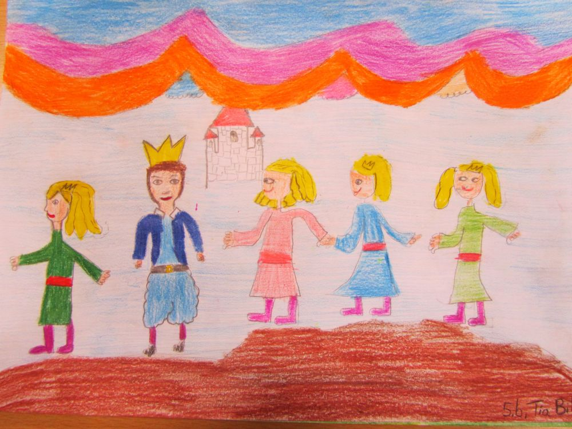
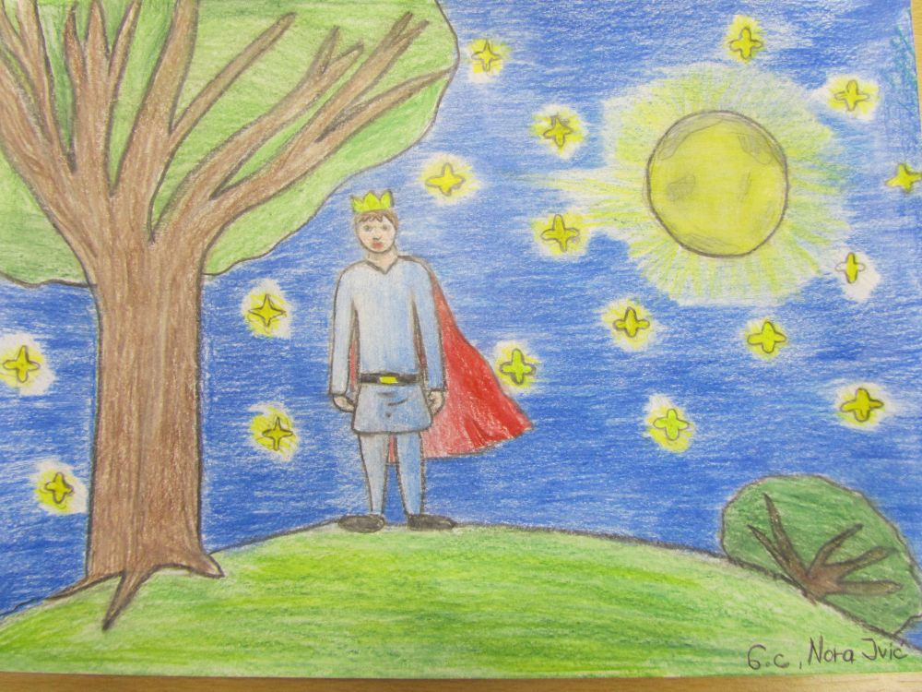
At the stroke of midnight, the Prince went for a moonlight stroll in the garden. The moon was shining brightly and the lovely frangrance of the lime-trees was in the air.
Suddenly the Prince stopped and in front of him stood a little fairy. The fairy told him that she was also invited to the ball, but she couldn't come becouse she was so small. And now in the moonlight she is able to bow before him.
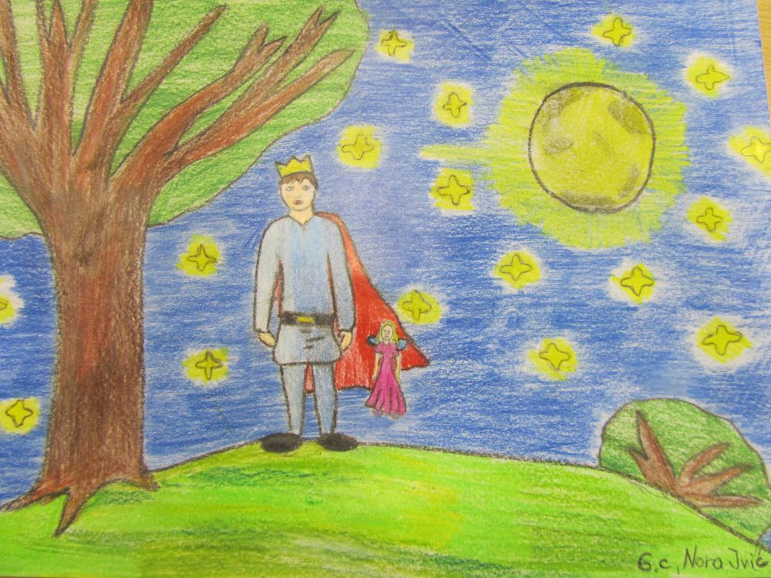
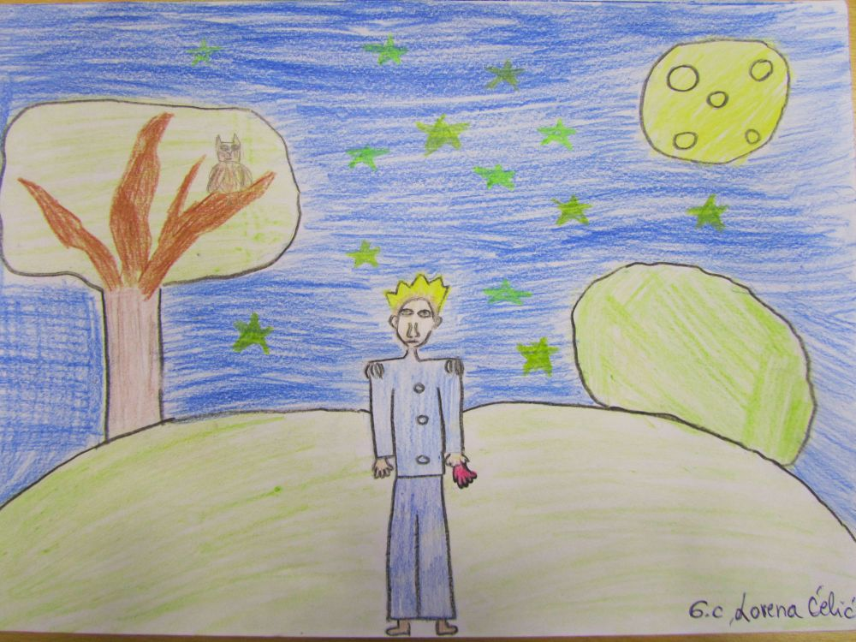
The Prince liked the little fairy. He stepped closer and took her hand. She disappeared, but she left her glove in his hand.
Next night the Prince once again went for a walk in the garden looking for the fairy. He took her glove out of his pocket, loked at it and kissed it. All at once the fairy appeared before him. They walked together in the moonlight talking all the while. The fairy grew bigger and bigger.
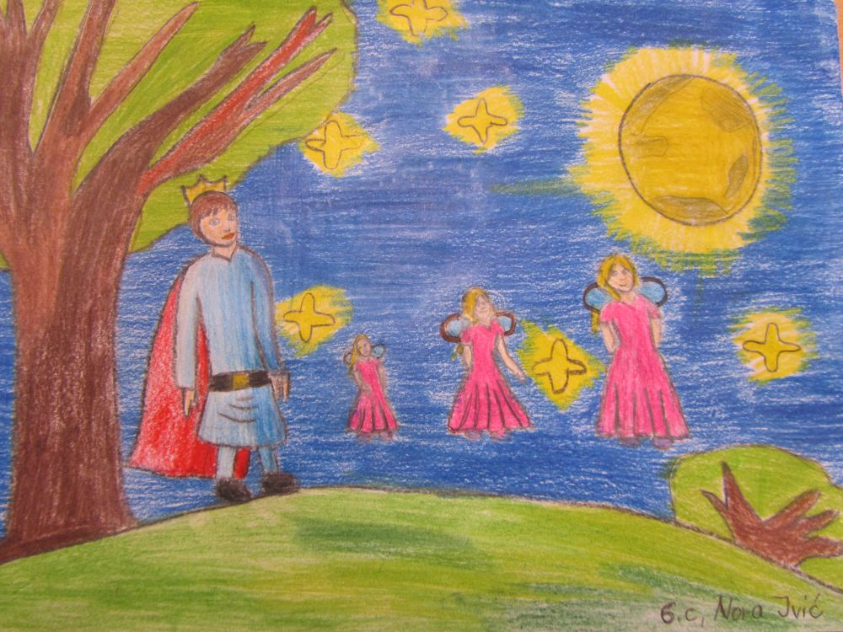
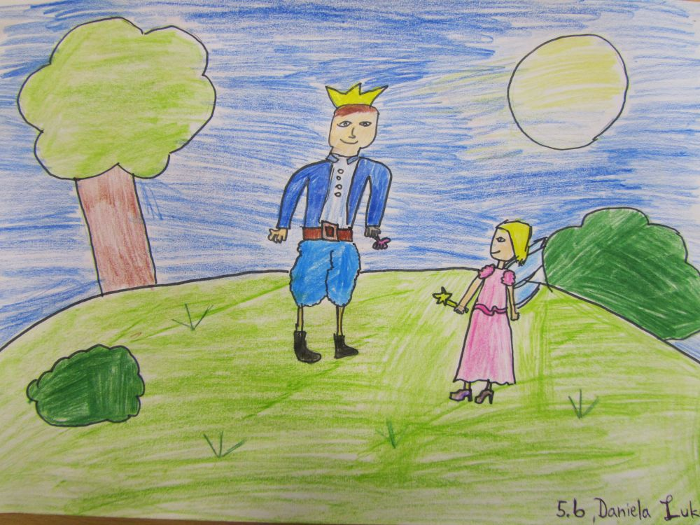
Every night after that they met in the garden. The fairy grew completely. The Prince fell in love with the little fairy. After 9 nights he asked her to marry him.

The fairy agreed to marry him, however under one condition. He would have to love her always and only then she could be truly his.
After 3 days they had a big wedding celebration and lived happily for 7 years.
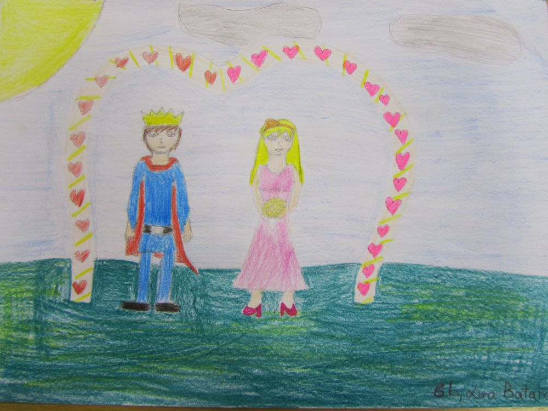
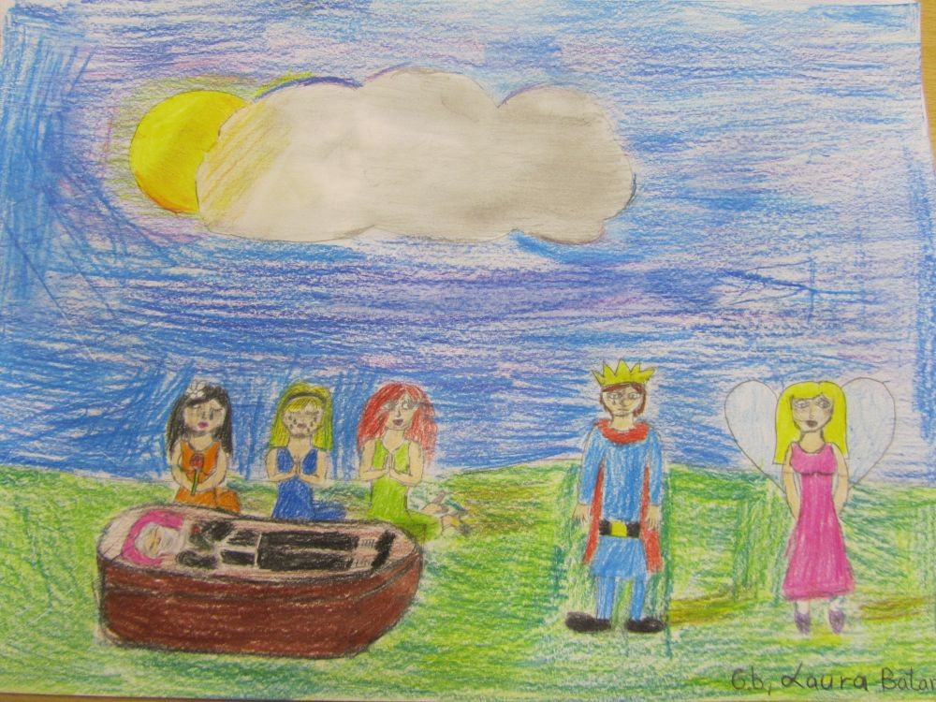
One day the old King died. At the funeral there were many people. One of them a girl with red hair and dark eyes. Her gaze was fixed on the Prince, he felt pleasure. He was looking at her too.
As he continued to gaze at the girl, his wife grew smaller and smaller. She became so small that her dress was too long. When they got home she completely dissappeared.
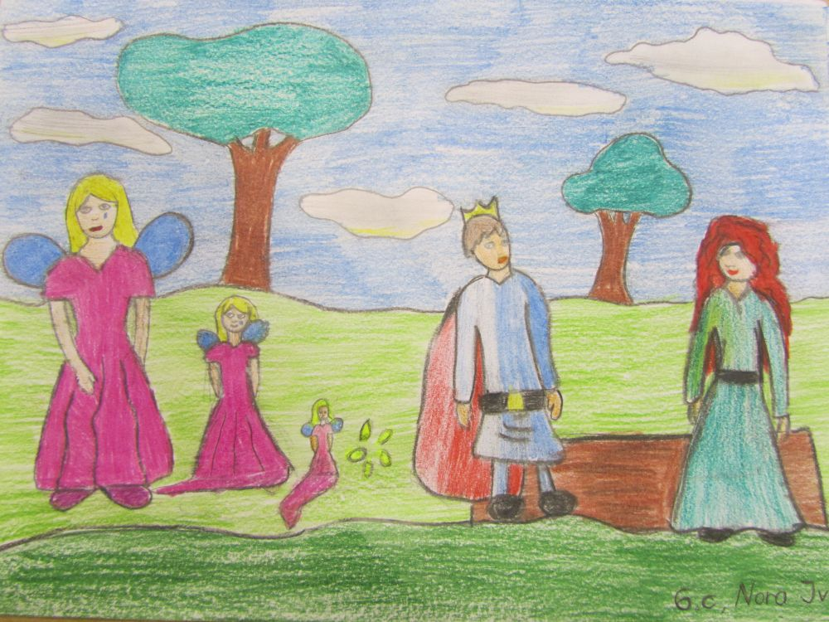
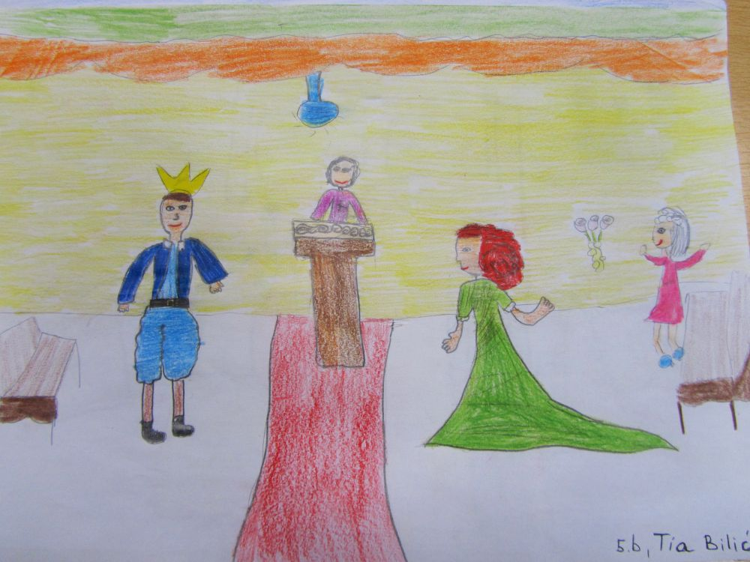
Then the Prince married the girl with the red hair and dark eyes.

After just 3 days he was unhappy because she was always complaining and wanted him to buy her expensive things. When she couldn't get what she wanted, she would cry and argue with him. He couldn't stand it anymore, so he banished her.
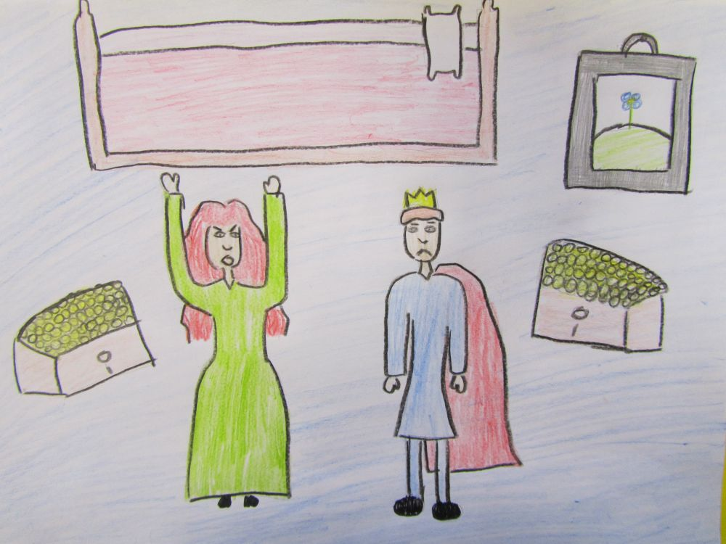
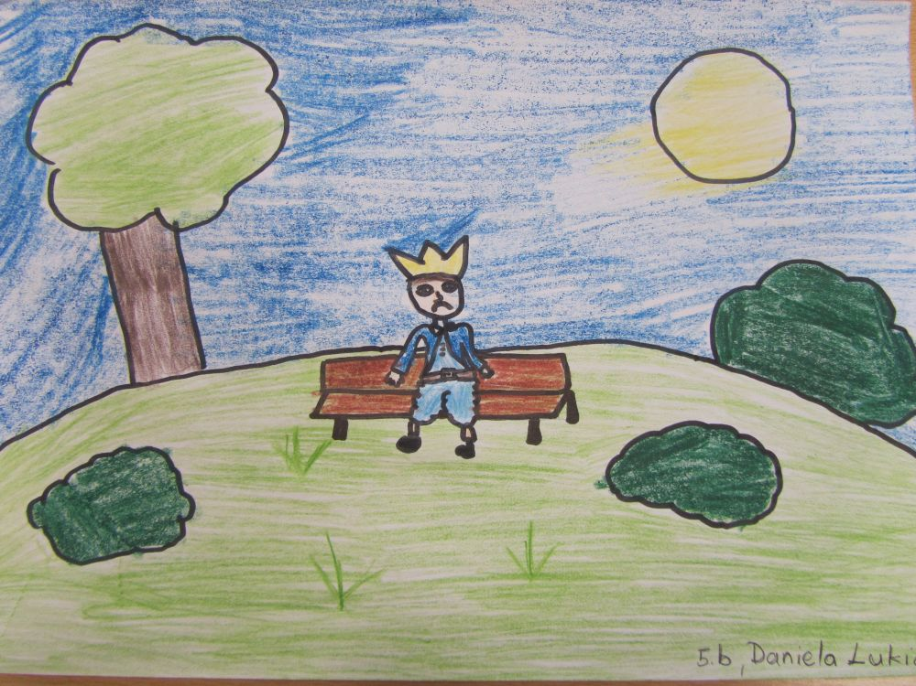
He started thinking about his little fairy. Every night he would go for a walk in the garden, hoping for her return. He waited and waited. He became and old man, but she never returned...
Made by: „Young Librarians“

